

**CMPE 211 Project Design Report**

Project Name : ***TEDUpolly***

Group Name : **La Petit Project (Section 1)**

Group Members :

* Fuat Yiğit KOÇYİĞİT - 16429085948
* Günsu GÜNAYDIN - 18098680134
* Sudenur ATA - 10014062970
* Yunus NOGAY – 41953436140

**Contents**

* Design Plan and Class Diagrams (3)
* Workload Division (4)

**Design Plan and Class Diagrams**

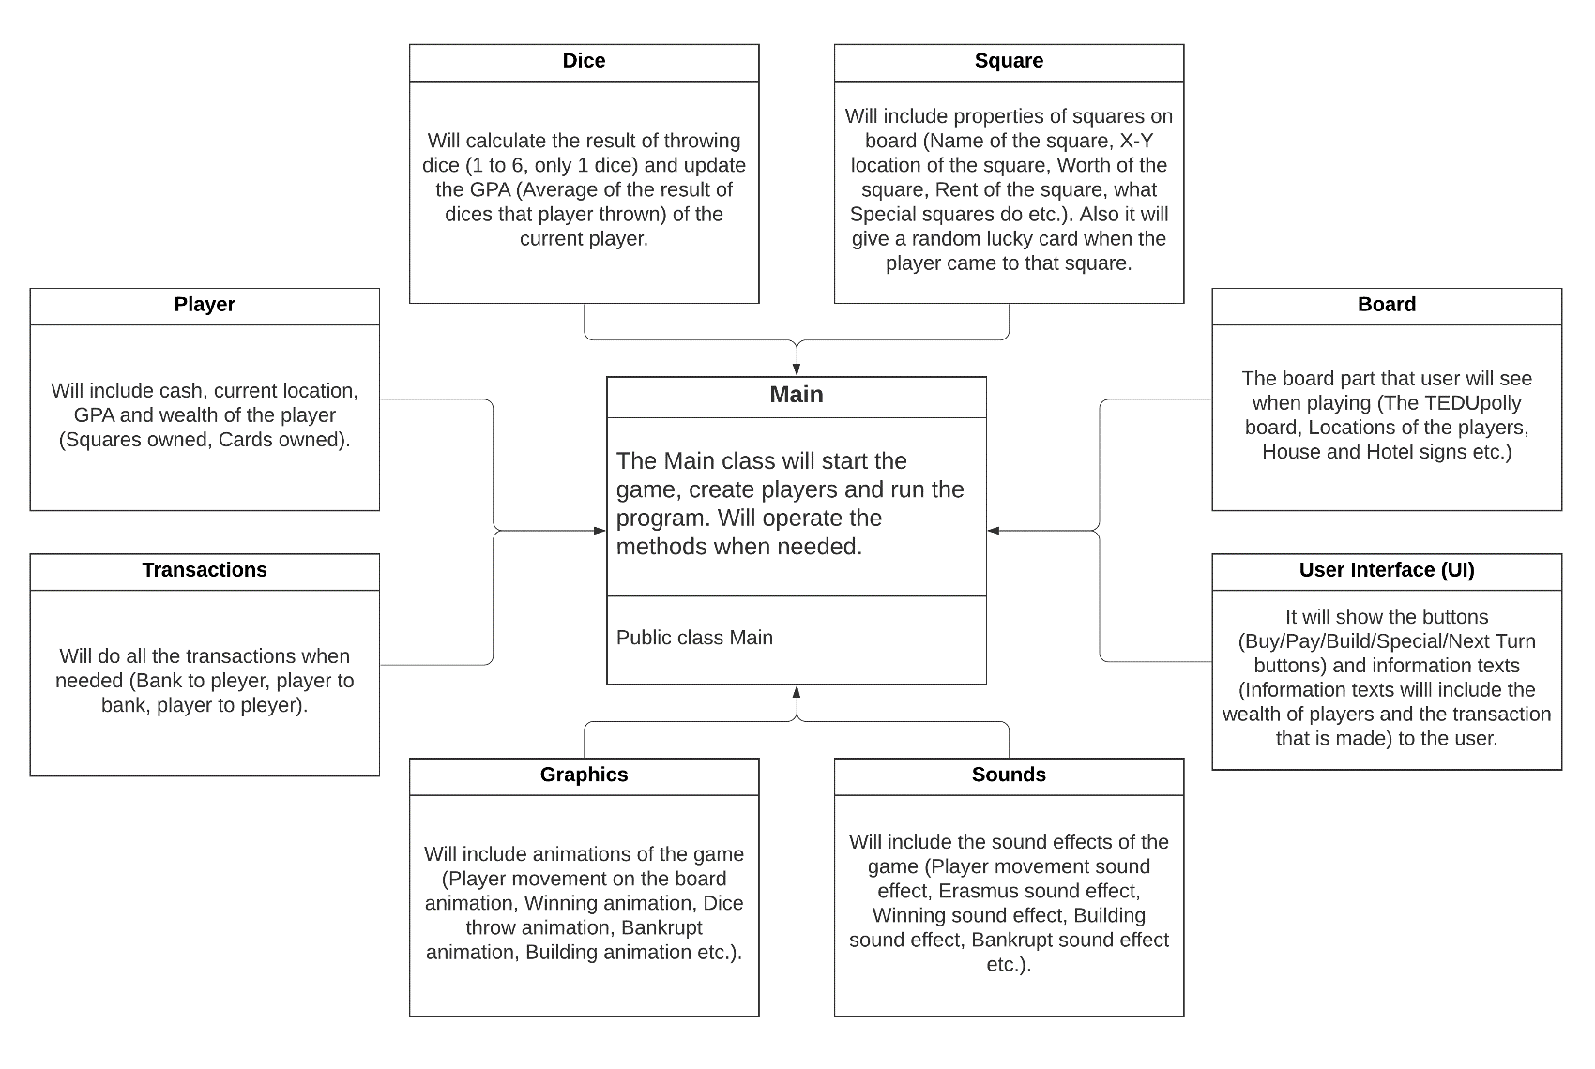

UML Diagram of TEDUpolly game

We are still doing researches about some things like User Interface, Special Effects (Graphical effects and Sound effects), doing some little or big changes and some method changes in our group project. So, these classes and their purposes may change but the general design plan for our TEDUpolly game is like that UML Diagram above.

**Workload Division**

* Fuat Yiğit Koçyiğit: Main Part (Main class)
* Günsu Günaydın: Visual Interface Part (User Interface and Board classes)
* Sudenur Ata: Methods Part (Dice, Player, Transactions and Square classes)
* Yunus Nogay: Graphic and Effects Part (Graphics and Sounds classes)

*The workload divisions are not fully certain. We may change and arrange the workload divisions according to the requirements.